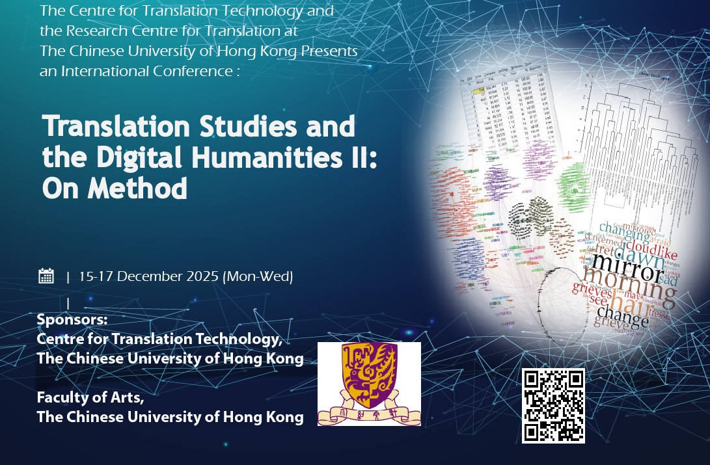

**Translation Studies and Digital Humanities II: On Method**

**Call for Panels**

1. Each panel consists of 3 or 4 scholars, including one chairperson to host the panel session.

2. Please send completed form to [dhintranslation@cuhk.edu.hk](mailto:dhintranslation@cuhk.edu.hk) on or before **30 July 2025**.

|  |
| --- |
| **Panel Details** |
| Panel Title: |
| Panel Abstract (No more than 150 words): |
| Chairperson (may be one of the presenters): |

|  |  |
| --- | --- |
| **Personal Particulars** | |
| **Member 1** | |
| Name: | |
| Title: ❒Prof. ❒Dr. ❒Mr. ❒Ms. | |
| Correspondence Address: | |
| Office/Mobile Telephone: | E-mail Address: |
| Name of Affiliated Institute: | |
| Name of Affiliated Department: | |
| Position Held (Please write “PhD/MPhil candidate” if you are a student): | |
| Please Provide a Short Biography (No more than 100 words): | |
| Title of Paper: | |
| Abstract (No more than 400 words): | |

|  |  |
| --- | --- |
| **Personal Particulars** | |
| **Member 2** | |
| Name: | |
| Title: ❒Prof. ❒Dr. ❒Mr. ❒Ms. | |
| Correspondence Address: | |
| Office/Mobile Telephone: | E-mail Address: |
| Name of Affiliated Institute: | |
| Name of Affiliated Department: | |
| Position Held (Please write “PhD/MPhil candidate” if you are a student): | |
| Please Provide a Short Biography (No more than 100 words): | |
| Title of Paper: | |
| Abstract (No more than 400 words): | |

|  |  |
| --- | --- |
| **Personal Particulars** | |
| **Member 3** | |
| Name: | |
| Title: ❒Prof. ❒Dr. ❒Mr. ❒Ms. | |
| Correspondence Address: | |
| Office/Mobile Telephone: | E-mail Address: |
| Name of Affiliated Institute: | |
| Name of Affiliated Department: | |
| Position Held (Please write “PhD/MPhil candidate” if you are a student): | |
| Please Provide a Short Biography (No more than 100 words): | |
| Title of Paper: | |
| Abstract (No more than 400 words): | |

|  |  |
| --- | --- |
| **Personal Particulars** | |
| **Member 4 (if applicable)** | |
| Name: | |
| Title: ❒Prof. ❒Dr. ❒Mr. ❒Ms. | |
| Correspondence Address: | |
| Office/Mobile Telephone: | E-mail Address: |
| Name of Affiliated Institute: | |
| Name of Affiliated Department: | |
| Position Held (Please write “PhD/MPhil candidate” if you are a student): | |
| Please Provide a Short Biography (No more than 100 words): | |
| Title of Paper: | |
| Abstract (No more than 400 words): | |